Your pick: World's 50 best foods
The world has voted and we now know the name and origin of the world's best food. But have you eaten it?
By Tim Cheung 7 September, 2011
What are the world's best foods? We thought we knew. Apparently we don't.
Our list of the World's 50 best foods stimulated some impassioned debate about the conspicuous lack of French dishes and the merits of ketchup over mayonnaise.
“Ketchup? Pop Corn? Chips? Plenty of Thai but few Malay food? What about Chinese (Sichuan, Cantonese, etc)? No Brazilian or Argentinean?” queried commenter Max.
Reader LoveFoods wrote, "OMG why are people hating? If you don't like the list, make your own! I love Thai and Japanese foods."
LoveFoods was right. So we threw it open to a vote on a Facebook poll.
And now, after more than 35,000 votes, it appears we got it all wrong. The world’s most delicious food is not Massaman curry, as we suggested, but a meaty, spicy, gingery dish from west Sumatra.
Couscous and lemon curd cake both took scores of votes, but didn't make the list. Some 439 people thought gelato deserved a place in online history.
The world's 50 best foods according to CNNGo readers are below. Bon appetit.

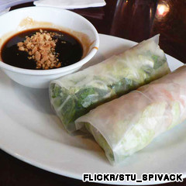50. Little packages of delightful best food freshness.

50. Goi cuon, Vietnam
This snack made from pork, shrimp, herbs, rice vermicelli and other ingredients wrapped in rice paper is served at room temperature. It’s “meat light,” with the flavors of refreshing herbs erupting in your mouth.
Dipped in a slightly sweet sauce laced with ground peanuts, it’s wholesome, easy and the very definition of “moreish.”
49. Great tan, better taste.

49. Lechon, Philippines
Young pigs, chosen for their tender meat, are rotated and roasted thoroughly over a fire pit for hours. The result is a thin layer of crispy skin on juicy, succulent meat. Every mouthful makes you wonder why you eat anything else.
Great way to kick off this list.
Also on CNNGo: The making of Bali's incredible pig roast
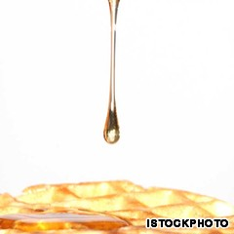46. Canada's best food.

48. Parma ham, Italy
Possibly the most versatile and best food of all. You see it folded around melon, wrapped around grissini, placed over pizza, heaped over salad.
There’s good reason for that: these salty, paper-thin slices of air-dried ham lift the taste of everything they accompany to a higher level, following the same theory as the Italian guy who thinks carrying around a copy of “Candide” makes up for the tiny Speedos.
Also on CNNGo: 11 artery-clogging and delicious Vietnamese dishes
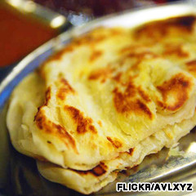45. A flippin' great dish.

47. Fettucini alfredo, Italy
Saying no to fettucini alfredo is like turning down MonicaBellucci. It's just wrong.
The main ingredients are butter and Parmesan cheese; it's rich and creamy and it can be made in 15 minutes (consumption time included). A good serving of this can turn dinner with the family into something you actually look forward to.
42. Yes I love you. Now gimme a bite.

46. Maple syrup, Canada
With poutine and Montreal-style smoked meat not making the top 50, maple syrup becomes the sole Canadian representative in the list. But before selling you on its natural flavor and balanced sweetness, we must give credit to its mentor, the waffle, playing Batman to maple syrup's edgier, sexier Robin.
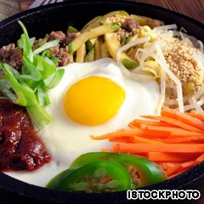40. See, healthy food can taste good.

45. Roti prata, Singapore
The truth is curry wouldn't be curry if it wasn't for this dough-based pancake.
Looks and tastes like Indian naan, roti prata is flipped and turned and flipped again before it's heated over a grill plate. Its preparation is so theatrical you'll feel like dancing a jig while you're eating it.

44. Laksa, Singapore
Whether it originates in Singapore, Malaysia or Indonesia as reader Bob Haris Mandela claimed, an authentic bowl of laksa always comes with slippery vermicelli, a spicy broth (the spicier the better), generous toppings of shredded chicken and fresh prawns.
One whiff of its pungent curry-coconut aroma and you'll be transported to all three countries. Best way to travel ever.
Also on CNNGo: 40 delicious Singapore foods
39. Breakfast for one billion people.

43. Fajitas, Mexico
This assembly kit of a dining experience is a thrill to DIY enthusiasts everywhere.
Step 1: Behold the meat sizzling on a fiery griddle. Step 2: Along with the meat, throw side servings of capsicum, onion, guacamole, sour cream and salsa into a warm, flour tortilla. Step 3: Promise all within hearing range that you’ll have “just one more.” Step 4: Repeat.
38. The dessert you can use to compare all the world's restaurants.

42. Hamburger, Germany
When something tastes so good that people spend US$20 billion each year in a single restaurant chain devoted to it, you know it has to fit into this list. McDonald’s may not offer the best burgers, but that’s the point -- it doesn’t have to.
The bread-meat-salad combination is so good that entire countries have ravaged their eco-systems just to produce more cows. A global best food contender.

41. Galbi, Korea
"Yeah, I would have thrown Kalbi Jim or something similar on there," wrote reader Nobody. "Some Korean dishes are savagely good."
We could forgive Nobody for opening 222 Facebookaccounts to put Galbi in the list. But we're pretty sure thebalance of sweet and savory in Korean short ribs means there's no underhand vote-rigging required.
Also on CNNGo: Best 7 restaurants for the Seoul herbivore
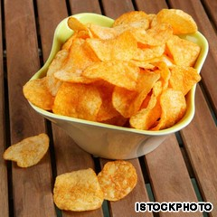37. The world's cheapest delicacy?

40. Bibimbap, Korea
Mixed vegetables and beef, sitting atop steaming-hot rice, held together by a half-raw egg. The beauty of this Korean dish lies at least partially in the diner's DIY mixing of the ingredients.
Bibambap is best when served in a heated stone bowl, and eaten with metal chopsticks.

39. Masala dosa, India
A crispy, rice-batter crepe encases a spicy mix of mashed potato, which is then dipped in coconut chutney, pickles, tomato-and-lentil-based sauces and other condiments. It’s a fantastic breakfast food that’ll keep you going till lunch, when you’ll probably come back for another.
Also on CNNGo: 40 delicious Mumbai foods
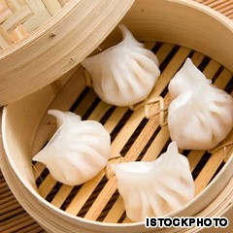34. Small but brilliant.

38. Warm brownie and vanilla ice cream, Global
There are some diners who will not frequent an establishment if it does not have brownie and ice cream on the dessert menu. You may call them fools.
We do, too, but having done so we then happily leave the first restaurant after the main course to visit one we know has this perfect dessert on offer.
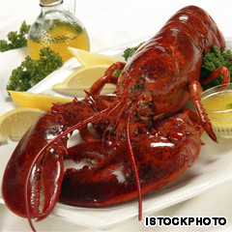32. If you were on a million menus you'd have big claws too.

37. Potato chips, United States
Despite major criticisms suggesting that potato chips aren't real food, voters like Deepti Ravi believe that they "rock."
What started as a chef's trick on a fussy diner is now one of the world’s most child-friendly foods. But think of them this way -- if a single chip cost, say, US$5, it’d be a far greater (and more popular) delicacy than caviar, a prize worth fighting wars over.
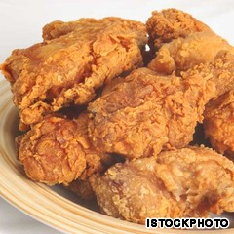31. Clucking great.

36. Moo nam tok, Thailand
Grilled pork combined with lemon juice, green onions, chili, mint sprigs, fish sauce and toasted rice. Legend has it the blood from the meat along with the dressing inspired some happy carnivore to name this brilliant dish “waterfall (nam tok moo) meat.”

35. Neapolitan pizza, Italy
The best pizza was and still is the simple Neapolitan, an invention now protected by its own trade association that insists on sea salt, high-grade wheat flour, the use of only three types of fresh tomatoes, hand-rolled dough and the strict use of a wood-fired oven, among other quality stipulations.
With just a few ingredients -- dough, tomatoes, olive oil, salt and basil (the marinara pizza does not even contain cheese) -- the Neapolitans created a best food that few make properly, but everyone enjoys thoroughly.

34. Shrimp dumpling, Hong Kong
Succulent shrimps, steamed well but not overdone, wrapped inside translucent rice paper. This simple form of dim sum has been a must-eat dish for decades.
Also on CNNGo: 40 delicious Hong Kong foods
Words on the street say the more pleat folds there are the more skillful the chef is.

33. Seafood paella, Spain
The sea is lapping the shore by your feet, a warm breeze whips the tablecloth around your legs and a steamy pan of paella sits in front of you. Shrimp, lobster, mussels and cuttlefish combine with white rice and various herbs, oil and salt in this Valencian dish to send you immediately into holiday mode.
Though if you have it in Spain, you’re probably there already.

32. Lobster, Global
Forget all your fancy, contrived lobster dishes deployed by showoff chefs eager for Michelin endorsement. When you have something as naturally delicious as these little fellas, keep it simple. The best way to enjoy lobster is simply to boil it and serve with a side of melted butter and slice of lemon.

31. Fried chicken, United States
"I have had almost everything. But they left off fried chicken... " reader Michelle Souzacommented.
Michelle: your fellow readers have made up for this unforgivable lapse. This all-time American favorite makes its entry with all the artery-choking goodness that made Colonel Sanders a very happy, if not healthy, man.
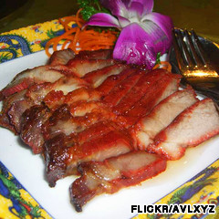28. The best pork comes barbecued and honey-drizzled.

30. Cheeseburger, United States
The power of cheese? Add it to an ordinary hamburger, the food gets pushed up 13 spots in the poll.
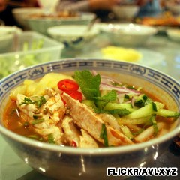26. As photogenic as the best food gets.

29. Chili crab, Singapore
Reader ST suggested that chili crabs, contrary to popular beliefs, aren't difficult to make. "Fantastic list of delicious food! Chilli Crabs are actually very easy to prepare. Here is an easy recipe for you :)"
ST forgot to mention, however, that it is difficult to stop eating this high-ranking best food.
Also on CNNGo: Food fight! Malaysia wants its 'unique' dishes back
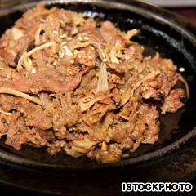23. The messiest, meatiest food for champions.

28. Barbecue pork, Hong Kong
Along with many comments left by reader Louis4, s/he wrote, "TX bbq tastes like turds. Is that all you have beside that boring food?"
Here you go, Louis4. Your fellow readers suggested the Chinese version of barbecue pork. This honey-coated meat is sweet, tender and it goes well with everything -- rice, noodles or even by itself.
Ask for the half-fat, half-lean barbecue pork to really indulge in this delicacy.
22. Egg on your face can be a good thing.

27. Tacos, Mexico
A fresh, handmade tortilla stuffed with small chunks of grilled beef rubbed in oil and sea salt then covered with guacamole, salsa, onions, cilantro or anything else you want -- perfect for breakfast, lunch or dinner. This is the reason few visitors leave Mexico weighing less than when they arrived.
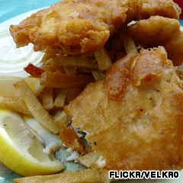21. A salty, vinegary homage to the basics.

26. Penang assam laksa, Malaysia
Poached, flaked mackerel, tamarind, chili, mint, lemongrass, onion, pineapple … one of Malaysia’s most popular dishes is an addictive spicy-sour fish broth with noodles (especially great when fused with ginger), that’ll have your nose running before the spoon even hits your lips.

25. Chocolate, Mexico
The Mayans drank it, Lasse Hallström made a film about it and the rest of us get over the guilt of eating too much of it by eating more of it. The story of the humble cacao bean is a bona fide out-of-the-jungle, into-civilization tale of culinary wonder.
Without this creamy, bitter-sweet confection, Valentine’s Day would be all cards and flowers, Easter would turn back into another dull religious event and those halcyon days of gorging yourself to eruption point at Christmas would be fanciful imaginings.
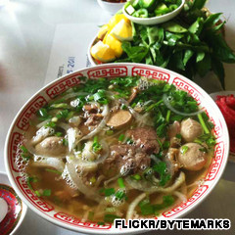20. Vietnam's answer to "What should I eat today?"

24. Fried rice, Thailand
It's true, anyone can fry rice. But can you fry it as well as the Thais? We suspect not.
Also on CNNGo: 40 delicious Thai foods

23. Bulgogi, Korea
Literally meaning "fire" and "meat," this Korean dish has been in existence for nearly 1,000 years.
A bowl of bulgogi gives everything you need in a balanced diet -- carbohydrate (rice), protein (beef and egg), vitamins and minerals (mixed vegetables), and fat (oil). Four good reasons to order a second bowl.
Also on CNNGo: Buldak: South Korea's torturous but irresistible dish
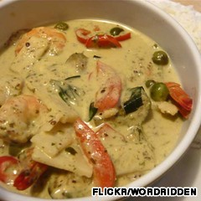19. It's easy eating green.

22. Egg tart, Hong Kong
Flaky on the crust with a sweet and smooth egg custard in the middle, egg tarts are best eaten hot when they're fresh out of an oven. This dessert can be ordered in the most rundown bakeries and most glamorous hotels inHong Kong.
Former Governor of Hong Kong, Chris Patten, declared eating egg tarts one of his favorite pastimes in the city.
Also on CNNGo: Behind the scenes of Hong Kong's most loved egg tart bakery
17. So many flavors to choose. Why bother?

21. Fish 'n' chips, England
Anything that’s been around since the 1860s can’t be doing much wrong. The staple of the Victorian British working class is a crunchy-outside, soft-inside dish of simple, un-adorned food fundamentals.
Sprinkled with salt, vinegar and dollops of tartar sauce, it is to nouveau cuisine what Meat Loaf is to Prince (or whatever he's calling himself now).

20. Pho, Vietnam
This oft-mispronounced national dish (“fuh” is correct) is just broth, fresh rice noodles, a few herbs and usually chicken or beef. But it’s greater than the sum of its parts -- fragrant, tasty and balanced, the polar opposite of themoto rider who brought you to the little café where you find the best stuff.

19. Green curry, Thailand
Kermit got it wrong. It's not hard being green, it's delicious. For many this coconutty-creamy and spicy curry should have made the top 10. Goes with steamed rice like bikinis go with Thai beaches.
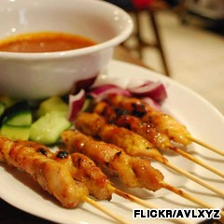14. Stick it, soak it, eat it, lick it.

18. Croissant, France
Flaky pastry smothered in butter, a pile of raspberry jam smeared over the top and a soft, giving bite as you sink in your teeth; there’s nothing not to love about this fatty, sweet breakfast food that must be married to a cup of strong coffee.
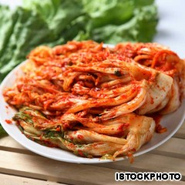12. How much money have Korean restaurants lost out on by giving this away for free?

17. Gelato, Italy
Thanks to "Eat, Pray, Love," the best dessert in Italy is now more popular than ever. True gelato makers use only fresh ingredients and no artificial flavors or colors, and allow you to mix and match as many different flavors as you want.
With a higher density and less fat than ice cream, gelatooften tastes richer but healthier -- perfect for your own "no-carb-left-behind" experiment.
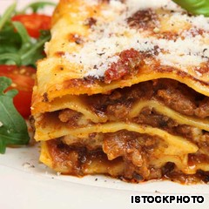11. Lasagna is right on so many levels.

16. Kebab, Turkey
For keeping starvation at bay for the entire student population of the United Kingdom, the doner kebab should clearly be honored. But they are hardly the delicious prototype worthy of representing a region.
Reader Elena Vorobyeva told us, "There are so many forms and shapes of it: doner, iskender kebab, shishkebab, chop shish kebab, orman kebab, etc."
So summon the shish kebab. Pick your meat, shove a stick through it, grill. Then wonder why you don’t eat like this every day.

15. Ice cream, United States
Somehow there’s always room for a tooth-rotting, U.S.-style pile of ice cream with nuts, marshmallows and chocolate sauce.
Thank God for extra long spoons that allow you get at the real weight-gain stuff all mixed up and melted at the bottom of the glass. Other than a dietician, who wouldn't agree this is one of the best foods in the world?
Also on CNNGo: Best cold treats in Hong Kong

14. Satay, Indonesia
Reader Paul Peh wrote, "I can make satay too but the prep will take at least half the day and [the eating will be done] in less than half hr. lol."
Half an hour? What's the hold up? Last time we drowned some skewered meat with this peanut-based sauce we were ready for seconds before you could say "mmmm".

13. Chicken rice, Singapore
Often called the “national dish” of Singapore, this steamed or boiled chicken is served atop fragrant oily rice, with sliced cucumber as the token vegetable. Variants include roasted chicken or soy sauce chicken.
The dipping sauces -- premium dark soy sauce, chili with garlic and pounded ginger -- give it that little extra oomph to ensure whenever you’re not actually in Singapore eating chicken rice, you’re thinking of it.

12. Kimchi, Korea
Is Korea the most generous nation or what? Korean restaurants provide this starter dish of fermented vegetables for free. Perhaps because few Koreans can last more than two days without it.

11. Lasagna, Italy
Lasagna overtook pizza to become the most sought-after Italian food in this delicacy list. There’s a reason this pasta-layered, tomato-sauce-infused, minced-meaty gift to kids and adults alike is so popular -- it just works.
Dee Dodge wrote, "I love Lasagna." The lack of exclamation marks tells you how seriously true fans take this dish.
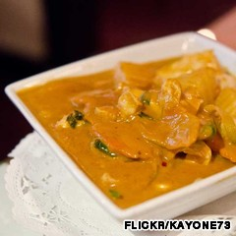10. Still a top 10 best foods entry.

10. Massaman curry, Thailand
Although not the world's most delicious food, it is still emphatically the king of curries. Spicy, coconutty, sweet and savory, its combination of flavors has more personality than a Thai election.
Even the packet sauce you buy from the supermarket can make the most delinquent of cooks look like a Michelin potential. Thankfully, someone invented rice, with which diners can mop up the last drizzles of curry sauce.
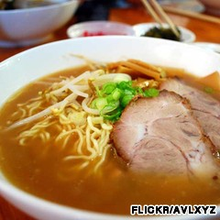8. World's loudest food?
“The Land of Smiles” isn’t just a marketing tag-line. It’s a result of being born in a land where the best curry is sold on nearly every street corner.

9. Peking duck, China
"Peking duck! its a wonder....." wrote Shan Cao on ourFacebook page.
We can only guess Shan Cao was in the middle of forking a piece of this maltose-syrup glazed duck dish into his/her mouth and forgot to finish the sentence. Slow-roasted in an oven, the crispy, syrup-coated skin is so good that authentic eateries will serve more skin than meat, and bring it with pancakes, onions and hoisin or sweet bean sauce.
Other than flying or floating, this is the only way you want your duck.
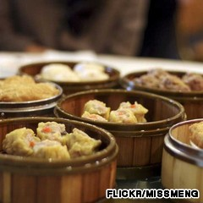7. Family lunches are fun again.

8. Ramen, Japan
Japanese protocol says the tastier your ramen is, the louder you should slurp it up to show respect to your chef. Not that they need more respect. One mouthful of this most Japanese of noodle broths will quickly tell you that either you have a ramen trigger in your brain, or Japanese chefs are geniuses.
Also on CNNGo: 40 delicious Japanese foods

7. Dim sum, Hong Kong
Equally fun and delicious to eat, a trip to Hong Kong isn't complete without trying this traditional Cantonese lunch food. Popular with everyone from pass-through tourists to local kids and the elderly, most dim sum come in bite-size pieces so you don't have to waste time cutting the stuff up.
Bring a few friends and wash the food down with the free-flow tea.
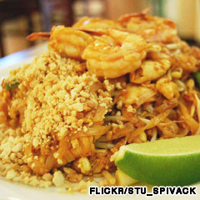5. Even better when it's messy.

6. Som tam (Papaya salad), Thailand
After reading reader Kun Chotpakdeetrakul's comment, "Papaya salad and som tam [are] the same thing. You should combine vote for these two together," we did just that, pushing som tam to just 80 votes shy of the top five.
To prepare Thailand's iconic salad, pound garlic and chilies with a mortar and pestle. Toss in tamarind juice, fish sauce, peanuts, dried shrimp, tomatoes, lime juice, sugar cane paste, string beans and a handful of grated green papaya.
Also on CNNGo: Everything you need to know aboutsom tam -- including where to find it
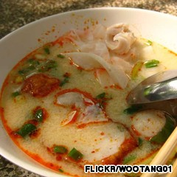4. Do you eat or drink soup? Either way just get it inside you.

5. Pad thai, Thailand
Here's a food Thai people can't live without.
Similar to Bulgogi (see #22), pad Thai is packed with nutrients stirred into one glorious fried-noodle dish.
The secret's in the sauce -- tamarind paste. If anyone ever creates a Hall of Food Fame, that should be first on the list.
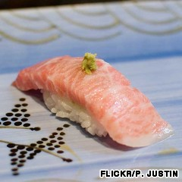3. Rice, salmon, wasabi -- world's best food trio?

4. Tom yam goong, Thailand
Reader Supot Sakulwongtana made it clear that "delicious includes a little bit hot." A little bit hot is right because you need room for a load more flavors too.
This Thai masterpiece teems with shrimp, mushrooms, tomatoes, lemongrass, galangal and kaffir lime leaves. Usually loaded with coconut milk and cream, the hearty soup unifies a host of favorite Thai tastes: sour, salty, spicy and sweet. Best of all is the price: cheap.
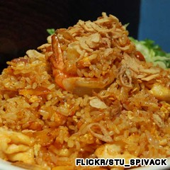2. More rice -- a common factor in many of these dishes.

3. Sushi, Japan
When Japan wants to build something right, it builds itreally right. Brand giants such as Toyota, Nintendo, Sony, Nikon and Yamaha may have been created by people fueled by nothing more complicated than raw fish and rice, but it’s how the fish and rice is put together that makes this a global first-date favorite.
This perfect marriage between raw fish and rice has easily kept sushi in the top five. And like one reader,Nymayor, wrote, "Now to be fair, DELICIOUS can be simple."
The Japanese don’t live practically forever for no reason -- they want to keep eating this stuff.
Also: How to eat sushi properly
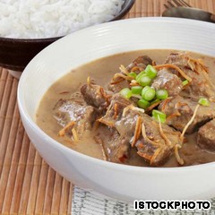1. 렌당, 인도네시아

2. Nasi goreng, Indonesia
"I like rendang and nasi goreng, two of most popular food in Indonesia!" Reader Rizky Ramadhika's got it. And thousands of other voters agreed.
The wonder of combining rice with egg, chicken and prawns strikes again. The second fried rice to make the list, this Indonesian delight received more than 10 times the vote of its Thai counterpart (see #23), propelling the former from non-runner to runner-up.
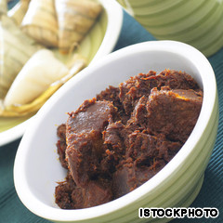1. No. 1 as voted by you.

1. Rendang, Indonesia
Reader Kamal F Chaniago showed great foresight when he wrote, "Rendang is the best." A clear winner with a loyal following, this beefy dish can now rightfully claim the title of "World's Most Delicious Food."
Beef is slowly simmered with coconut milk and a mixture of lemongrass, galangal, garlic, turmeric, ginger and chilies, then left to stew for a few hours to create this dish of tender, flavorful bovine goodness.
The Indonesian dish is often served at ceremonial occasions and to honored guests. It's not only delicious but also comes with a simple recipe. If you haven't already, go ahead and take reader Isabela Desita's advice: "Rendang should be the first! It's really nice, you should try!"

