50. The only food that tastes better when it's inside out.

50. Buttered popcorn, United States
Corn -- the workhorse of the industrial world -- is best when its sweet variety is fried up with lashings of butter till it bursts and then snarfed in greasy fistfuls while watching “Commando” late at night.
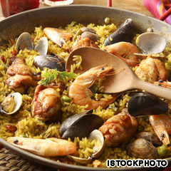47. So fresh you'll think it's flirting with you.

49. Masala dosa, India
A crispy, rice-batter crepe encases a spicy mix of mashed potato, which is then dipped in coconut chutney, pickles, tomato-and-lentil-based sauces and other condiments. It’s a fantastic breakfast food that’ll keep you going till lunch, when you’ll probably come back for another.
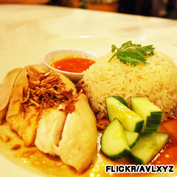45. The cucumber's an afterthought, the rest though is right on message.

48. Potato chips, United States
Potato chips were invented in New York when a chef tried to play a trick on a fussy diner. Now they’re one of the world’s most child-friendly and best foods. But think of them this way -- if a single chip cost, say, US$5, it’d be a far greater (and more popular) delicacy than caviar, a prize worth fighting wars over.
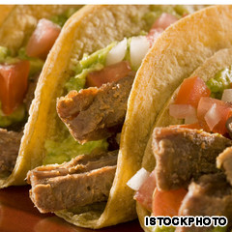43. Two tacos are just never enough. That's why it's one of our best foods.

47. Seafood paella, Spain
The sea is lapping just by your feet, a warm breeze whips the tablecloth around your legs and a steamy pan of paella sits in front of you. Shrimp, lobster, mussels and cuttlefish combine with white rice and various herbs, oil and salt in this Valencian dish to send you immediately into holiday mode.
Though if you have it in Spain, you’re probably there already.
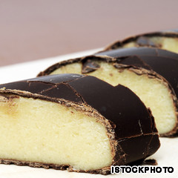40. How can something taste this good? It's just nuts.

46. Som tam, Thailand
To prepare Thailand's most famous salad, pound garlic and chilies with a mortar and pestle. Toss in tamarind juice, fish sauce, peanuts, dried shrimp, tomatoes, lime juice, sugar cane paste, string beans and a handful of grated green papaya.
Grab a side of sticky rice. Variations include those made with crab (som tam boo) and fermented fish sauce (som tam plah lah), but none matches the flavor and simple beauty of the original.
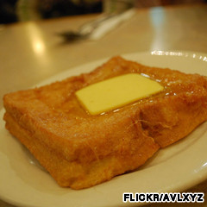38. A measly 500 calories is all this bad boy will cost you.

45. Chicken rice, Singapore
Often called the “national dish” of Singapore, this steamed or boiled chicken is served atop fragrant oily rice, with sliced cucumber as the token vegetable. Variants include roasted chicken or soy sauce chicken. However it's prepared, it's one of Singapore's best foods.
The dipping sauces -- premium dark soy sauce, chili with garlic and pounded ginger -- give it that little extra oomph to ensure whenever you’re not actually in Singapore eating chicken rice, you’re thinking of it.
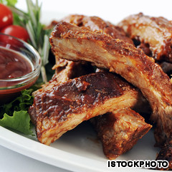36. Pigs can't fly, but they can grill beautifully.
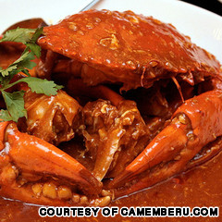35. As hot, and as tasty, as it looks.

44. Poutine, Canada
French fries smothered in cheese curds and brown gravy. Sounds kind of disgusting, looks even worse, but engulfs the mouth in a saucy, cheesy, fried-potato mix that’ll have you fighting over the last dollop.
Our Canadian friends insist it’s best enjoyed at 3 a.m. after “several” beers.
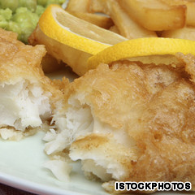33. It's not posh, it's not refined, but it is damn good eating.

43. Tacos, Mexico
A fresh, handmade tortilla stuffed with small chunks of grilled beef rubbed in oil and sea salt then covered with guacamole, salsa, onions, cilantro or anything else you want -- perfect for breakfast, lunch or dinner. This is the reason no visitor leaves Mexico weighing less than when they arrived.

42. Buttered toast with Marmite, Britain
OK, anything buttered is probably going to taste great, but there’s something about this tangy, salty, sour, love-it-or-hate-it yeast extract that turns a piece of grilled bread into a reason to go on living. For extra yum factor, add a layer of marmalade.
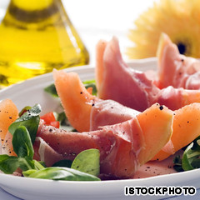31. Only ham this great can make fresh melon even better.

41. Stinky tofu, Southeast Asia
Nothing really prepares you for the stench of one of the strangest dishes on earth. Like durian, smelly tofu is one of Southeast Asia’s most iconic foods.
The odor of fermenting tofu is so overpowering many aren’t able to shake off the memory for months. So is the legendarily divine taste really worth the effort? Sure it is.

40. Marzipan, Germany
Don’t be fooled by cheap imitations, which use soy paste or almond essence. The real stuff, which uses nothing but ground almonds with sugar, is so good, you’ll eat a whole bar of it, feel sick, and still find yourself toying with the wrapper on bar number two.
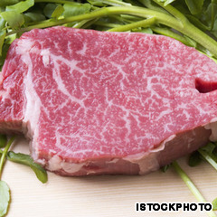29. Handle with care, devour with gusto.

39. Ketchup, United States
If Malcolm Gladwell says it’s a perfect food, then it’s a perfect food. Let’s face it, anything that can convince two-year-olds to eat their carrots rather than spitting them onto the floor is worthy of not just a “delicious” title, but a “miracle of persuasion” title, too.
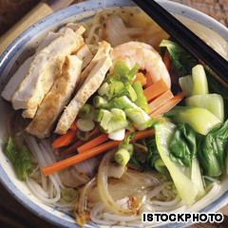28. Spare us the just-add-water pots, this is what real noodles should look like.

38. French toast, Hong Kong
Unlike its more restrained Sunday brunch counterpart, Hong Kong-style French toast is like a deep-fried hug. Two pieces of toast are slathered with peanut butter or kaya jam, soaked in egg batter, fried in butter and served with still more butter and lots of syrup. A Hong Kong best food, best enjoyed before cholesterol checks.
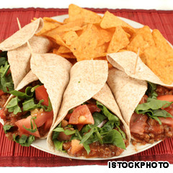26. If only every food could be wrapped in a tortilla.

37. Chicken parm, Australia
Melted Parmesan and mozzarella cheese, and a peppery, garlicky tomato sauce drizzled over the top of a chicken fillet -- Aussie pub-goers claim this ostensibly Italian dish as their own. Since they make it so well, there's no point in arguing.

36. Texas barbecue pork, United States
A saucy mash of chili, tomatoes, onions, pepper and various herbs gives each barbecue chef his or her own personalized zing to lay on top of perfectly prepped pig. Like the Texas sky, the options are endless.

35. Chili crab, Singapore
You can’t visit Singapore without trying its spicy, sloppy, meaty specialty. While there are dozens of ways to prepare crab (with black pepper, salted egg yolk, cheese-baked, et cetera) chili crab remains the local bestseller.
Spicy chili-tomato gravy tends to splatter, which is why you need to mop everything up with mini mantou buns.

34. Maple syrup, Canada
Ever tried eating a pancake without maple syrup? It’s like eating a slice of cardboard. Poorly prepared cardboard.
In fact, Canada’s gift to parents everywhere -- throw some maple syrup on the kid’s broccoli and see what happens -- makes just about anything worth trying. Pass the cardboard, please.

33. Fish ‘n’ chips, Britain
Anything that’s been around since the 1860s can’t be doing much wrong. The staple of the Victorian British working class is a crunchy-outside, soft-inside dish of simple, un-adorned fundamentals.
Sprinkled with salt, vinegar and dollops of tartar sauce, it is to nouveau cuisine what Meat Loaf is to Prince (or whatever he's calling himself now).

32. Ankimo, Japan
So, who’s up for a chunk of monkfish liver with a little grated daikon on the side? Thought not -- still, you’re missing out on one of sushi’s last great secrets, the prized ankimo.
The monkfish/anglerfish that unknowingly bestows its liver upon upscale sushi fans is threatened by commercial fishing nets damaging its sea-floor habitat, so it’s possible ankimo won't be around for much longer.
If you do stumble across the creamy, yet oddly light delicacy anytime soon, consider a taste -- you won’t regret trying one of the best foods in Japan.

31. Parma ham, Italy
You see it folded around melon, wrapped around grissini, placed over pizza, heaped over salad.
There’s good reason for that: these salty, paper-thin slices of air-dried ham lift the taste of everything they accompany to a higher level, following the same theory as the Italian guy who thinks carrying around a copy of “Candide” makes up for the tiny Speedos.

30. Goi cuon (summer roll), Vietnam
This snack made from pork, shrimp, herbs, rice vermicelli and other ingredients wrapped in rice paper is served at room temperature. It’s “meat light,” with the flavors of refreshing herbs erupting in your mouth.
Dipped in a slightly sweet Vietnamese sauce laced with ground peanuts, it’s wholesome, easy and the very definition of “moreish.”

29. Ohmi-gyu beef steak, Japan
This premium Japanese Wagyu beef from famed Takara Ranch has been recognized by the Imperial Palace of Japan as one of the greatest beef stocks to be raised in the past 400 years.
Called the “Rolls-Royce” of beef, it’s best eaten sashimi style, anointed with a drizzle of kaffir lime and green tea sea salt. Marbled fat gives each mouthful texture as the beef melts away, leaving a subtle but distinctly classic beef flavor.

28. Pho, Vietnam
This oft-mispronounced national dish (“fuh” is correct) is just broth, fresh rice noodles, a few herbs and usually chicken or beef. But it’s greater than the sum of its parts -- fragrant, tasty and balanced, the polar opposite of the moto rider who brought you to the little café where you find the best stuff.

27. Montreal-style smoked meat, Canada
Day and night, lines form outside of Schwartz’s, Montreal’s best Hebrew delicatessen and Canada’s oldest. Here clerks slice up the best smoked meat in North America.
Following a 1928 recipe, the meat is cured for 10 days. Order your smoked beef sandwich medium-lean, heavy on the mustard, three pickles and with extra pommes frites, the way the Rolling Stones have supposedly enjoyed it.
Schwartz’s, 3895 St-Laurent, Montreal, Canada; +1 514 842 4813; www.schwartzsdeli.com

26. Fajitas, Mexico
This assembly kit of a dining experience is a thrill to DIY enthusiasts everywhere.
Step 1: Behold the meat sizzling on a fiery griddle. Step 2: Along with the meat, throw side servings of capsicum, onion, guacamole, sour cream and salsa into a warm, flour tortilla. Step 3: Promise all within hearing range that you’ll have “just one more.” Step 4: Repeat.
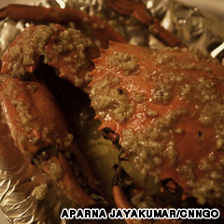25. Thankfully you don't have to catch these prickly fellas yourself.

25. Butter garlic crab, India
This one claims no roots in Chinese, Continental or Indian cuisines. It comes from Butter Land, an imaginary best foods paradise balanced on the premise that anything tastes great with melted butter.
This delicious, simple dish is made by drowning a large crab in a gallon of butter-garlic sauce, which seeps into every nook and cranny and coats every inch of flesh.
The sea gods of Butter Land are benevolent carnivores and this, their gift to the world, is their signature dish.
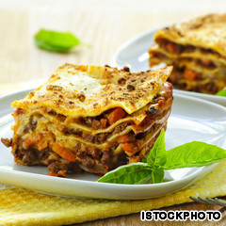23. So good, they gave it five levels.

24. Champ, Ireland
Irish national dish champ goes down faster than the first pint of Guinness on a Friday night. Mashed potato with spring onions, butter, salt and pepper, champ is the perfect side with any meat or fish.
For the textbook plate of creamy goodness, we suggest the busiest pub in any Irish seaside town. Around noon somehow feels right.
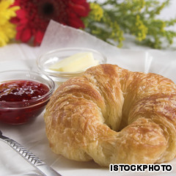21. Best way to eat this? In bed, at 3 p.m., in a gite in Brittany.

23. Lasagna, Italy
Second only to pizza in the list of famed Italian foods, there’s a reason this pasta-layered, tomato-sauce-infused, minced-meaty gift to kids and adults alike is so popular -- it just works.
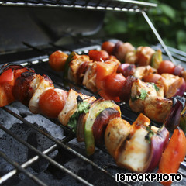18. It's as if sunny Sunday afternoons were created just for shish sizzlers.

22. Brownie and vanilla ice cream, global
There are some who will not frequent an establishment if it does not have brownie and ice cream on the dessert menu. You may call them fools.
We do, too, but having done so we then happily leave the first restaurant after the main course to visit one we know has this perfect dessert on offer.
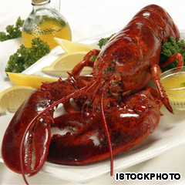17. If you were on a million menus you'd have big claws, too.

21. Croissant, France
Flaky pastry smothered in butter, a pile of raspberry jam smeared over the top and a soft, giving bite as you sink in your teeth; there’s nothing not to love about this fatty, sweet breakfast food that must be married to a cup of strong coffee.
14. Yeah, you'll get fat, but you'll have a great time doing so.

20. Arepas, Venezuela
A corn-dough patty that provides a savory canvas onto which you can paint any number of delicious toppings: cheese, shredded chicken, crisped pork skin, perico, beef, tomato, avocado … it’s the most beautiful thing to come out of Venezuela since all those Miss Universe winners.
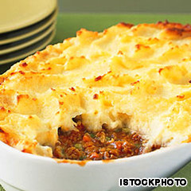12. Good food day and night, shepherd's delight?

19. Nam tok moo, Thailand
Grilled pork combined with lemon juice, green onions, chili, mint sprigs, fish sauce and toasted rice. Legend has it the blood from the meat along with the dressing inspired some happy carnivore to name this brilliant dish “waterfall (nam tok moo) meat.”
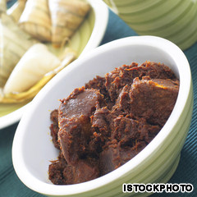11. Don't judge an awesome food by its dour appearance.

18. Kebab, Iran
For keeping starvation at bay for the entire student population of the United Kingdom, the doner kebab should clearly be honored. But they are hardly the delicious prototype worthy of representing a region.
For that, summon the shish kebab. Pick your meat, shove a stick through it, grill. Then wonder why you don’t eat like this every day.
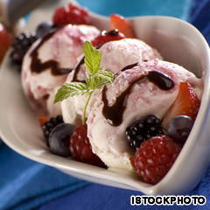9. Who put that stinking fruit in there?

17. Lobster, global
Forget all your fancy, contrived lobster dishes deployed by showoff chefs eager for Michelin endorsement. When you have a best food as naturally delicious as these little fellas, keep it simple. The best way to enjoy lobster is simply to boil it and serve with a side of melted butter and slice of lemon.
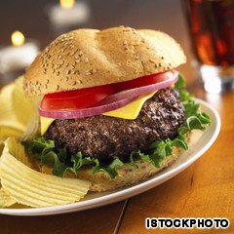6. The best cows come minced and in a bun.

16. Egg tart, Hong Kong
Like many classic dishes, the Hong Kong egg tart marries two contrasting textures: crusty, flaky pastry and jiggly, trembling custard. It’s sweet, it’s delicious and it’s best eaten hot from the oven on the street while queuing up to get just one more.

15. Kalua pig, United States
Only commercially available in Hawaii, the kalua preparation turns a meal into an epic event, with a whole pig roasted in an underground sand pit for six or seven hours.
But it’s not just for show. Smashed banana tree trunks, sea salt and shredded (never sliced) meat means this smoky, aromatic piece of pig will linger long on your tongue and even longer in your memory.

14. Donuts, United States
These all-American fried wheels of dough need no introduction, but we will say one thing: the delicious guilt of snacking on these addictive calorie bombs makes them taste even better. If that’s possible.

13. Corn on the cob, global
God probably created corn just to have an excuse to invent melted butter. There’s something about biting down on a cob of corn -- it’s a delicate enough operation to require concentration but primal enough to make you feel like the caveman you always wanted to be. Great food is caveman food.

12. Shepherd’s pie, Britain
Some might say England’s greatest inventions were the steam engine and the Jaguar E-Type. We like to think shepherd’s pie -- minced lamb topped with mashed potato -- comes somewhere in that list.
Tastes best at the end of a gloomy, rainy day with an open fire licking at the chimney breast and Ricky Gervais insulting people on the telly. Which is lucky, as that’s what most days are like in England.

11. Rendang, Indonesia
Beef is slowly simmered with coconut milk and a mixture of lemongrass, galangal, garlic, turmeric, ginger and chilies, then left to stew for a few hours to create this dish of tender, flavorful bovine goodness.
Tasting it fresh out of the kitchen will send your stomach into overdrive, but many people think it gets even better when left overnight.

10. Chicken muamba, Gabon
A bastardized Western version of this delectable Gabonese dish swamps everything in peanut butter. Oh, the insanity. The proper recipe calls for chicken, hot chili, garlic, tomato, pepper, salt, okra and palm butter, an artery-clogging African butter that will force you into a second helping and a promise to start using your gym membership.

9. Ice cream, United States
You may have just gorged yourself to eruption point, but somehow there’s always room for a tooth-rotting, U.S.-style pile of ice cream with nuts, marshmallows and chocolate sauce.
Thank God for extra long spoons that allow you get at the real weight-gain stuff all mixed up and melted at the bottom of the glass.

8. Tom yum goong, Thailand
This best food Thai masterpiece teems with shrimp, mushrooms, tomatoes, lemongrass, galangal and kaffir lime leaves. Usually loaded with coconut milk and cream, the hearty soup unifies a host of favorite Thai tastes: sour, salty, spicy and sweet. Best of all is the price: cheap.

7. Penang assam laksa, Malaysia
Poached, flaked mackerel, tamarind, chili, mint, lemongrass, onion, pineapple … one of Malaysia’s most popular dishes is an addictive spicy-sour fish broth with noodles (especially great when fused with ginger), that’ll have your nose running before the spoon even hits your lips.

6. Hamburger, Germany
When something tastes so good that people spend US$20 billion each year in a single restaurant chain devoted to it, you know it has to fit into this list. McDonald’s may not offer the best burgers, but that’s the point -- it doesn’t have to.
The bread-meat-salad combination is so good that entire countries have ravaged their eco-systems just to produce more cows.
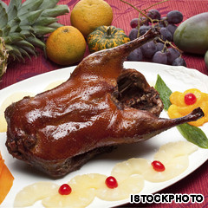5. A real quacker of a food.

5. Peking duck, China
The maltose-syrup glaze coating the skin is the secret. Slow roasted in an oven, the crispy, syrup-coated skin is so good that authentic eateries will serve more skin than meat, and bring it with pancakes, onions and hoisin or sweet bean sauce.
Other than flying or floating, this is the only way you want your duck.

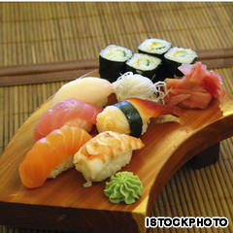4. If this was a "most beautiful" foods list, this would be no. 1.

4. Sushi, Japan
When Japan wants to build something right, it builds itreally right. Brand giants such as Toyota, Nintendo, Sony, Nikon and Yamaha may have been created by people fueled by nothing more complicated than raw fish and rice, but it’s how the fish and rice is put together that makes this a global first-date favorite.
The Japanese don’t live practically forever for no reason -- they want to keep eating this stuff.

3. Chocolate -- a bad husband's best friend.

3. Chocolate, Mexico
The Mayans drank it, Lasse Hallström made a film about it and the rest of us get over the guilt of eating too much of it by eating more of it. The story of the humble cacao bean is a bona fide out-of-the-jungle, into-civilization tale of culinary wonder.
Without this creamy, bitter-sweet confection, Valentine’s Day would be all cards and flowers, Easter would turn back into another dull religious event and those halcyon days of watching the dog throw up because you replaced the strawberry innards of the pink Quality Street with salt would be fanciful imaginings.

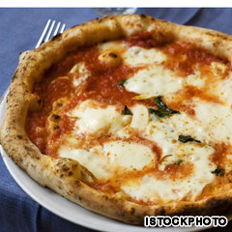2. No place for pepperoni in this list.

2. Neapolitan pizza, Italy
Spare us the lumpy chain monstrosities and “everything-on-it” wheels of greed.
The best pizza was and still is the simple Neapolitan, an invention now protected by its own trade association that insists on sea salt, high-grade wheat flour, the use of only three types of fresh tomatoes, hand-rolled dough and the strict use of a wood-fired oven, among other quality stipulations.
With just a few ingredients -- dough, tomatoes, olive oil, salt and basil (the marinara pizza does not even contain cheese) -- the Neapolitans created a food that few make properly, but everyone enjoys thoroughly.

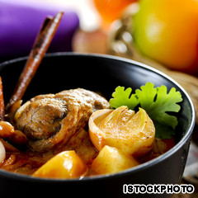1. One more reason to fall in love with Thailand.

1. Massaman curry, Thailand
Emphatically the king of curries, and perhaps the king of all foods. Spicy, coconutty, sweet and savory, its combination of flavors has more personality than a Thai election.
Even the packet sauce you buy from the supermarket can make the most delinquent of cooks look like a Michelin potential. Thankfully, someone invented rice, with which diners can mop up the last drizzles of curry sauce.
“The Land of Smiles” isn’t just a marketing catch-line. It’s a result of being born in a land where the world’s most delicious food is sold on nearly every street corner.

